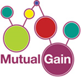
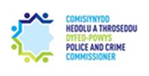
A Participatory Funding Event
Submit your bid for up to £2,500 for projects that will improve and promote wellbeing in your community
Mynydddu.communityfund@gmail.com
4pm-6pm Saturday 7th November 2020 (On-line)
Further updates on our social media pages (see below)
This application form is available in English and Welsh from our Facebook Page or on request.

Participatory Budgeting Funding Opportunity for Cwmamman & Quarter Bach

Funding local opportunities, working together with Mynydd Du Community Fund is offering community groups the chance to apply for funds through a process called Participatory Budgeting. Funding for this process has been supplied by:
- The Dyfed Powys Office of Police and Crime Commissioner
- Cwmamman Town Council
- Quarter Bach Council
- Betws Mountain Wind Farm Fund

Participatory Budgeting is a democratic way of empowering communities, by allowing them to bid for money to fund projects that meet the theme of the planning group; in this case improving community safety.

Any community group can bid for a share of the grant in order to improve and promote wellbeing in the community in Cwmamman and Quarter Bach.

If you require any information or help on completing your bid form then give us a message on our Facebook or twitter page. Details of when this will be held are available from our Facebook Page (Mynydd Du Community Fund) and Twitter Feed (@MynyddDuCommunityFund).

How does the Process work?

The Cwmamman and Quarter Bach community will decide who is awarded the money, and the process is as follows:

- Groups/organisations submit an application form for funding up to a maximum of £2,500 for their cause/project.
- This application form is checked to ensure that it meets the full criteria (set out below).
- The group/organisation will be contacted and be invited to attend the Participatory Budgeting Community Event.
- At the event, the community and other groups will be in attendance and they will vote on the projects being presented to them.
- Each group/organisation will be required to give a maximum 3 minute presentation/pitch to the community. This video clip can then be download to our e-mail address via my transfer website.
- Votes are collated, and the winning projects will be announced on the day.

What is the theme?

The funding is to be used in improving and promoting wellbeing in the community. This could be in supporting local groups to assist in reducing and preventing crime, to support victims or to support vulnerable members of our Cwmamman and Quarter Bach Community.

Any bids MUST have a connection to Improving and Promoting Wellbeing in the Community.

Examples of successful bidders in similar schemes include;

Boxing clubs, dance clubs, majorette and youth football clubs, a food bank project, a senior citizens computer club, a nursery group, playground improvement group, allotment societies, senior citizens dinner club, heritage and history groups, veterans group, mental health groups etc… The list is endless!

Eligibility Criteria?

- The maximum bid limit is £2,500
- Multiple bids from a single organisation will be accepted. However, there can only be a maximum number of three bids and they cannot exceed the £2,500 limit in total.
- Successful and unsuccessful applicants will be notified by letter.
- Those bidding can be from either constituted or un-constituted groups, meaning that a voluntary group, community group, charity, PTAs, sports clubs and any group that will benefit the Cwmamman and Quarter Bach community can apply.
- Although applicants do not have to be from a constituted group there either has to be evidence of an existing bank account or a process to have a constituted group manage the funding on their behalf.
- Those bidding can be from the public sector, provided, in the case of the public sector, that the bid was for a programme that is outside or their core curriculum or purpose.
- Bidders can be from outside Cwmamman and Quarter Bach, but all projects must benefit the community of Cwmamman and Quarter Bach.
- The minimum voting age is 11
- The minimum age for bidders is 13, but those between the ages of 13-16 must be accompanied by an adult (18+).

THOSE ATTENDING HAVE TO VOTE ON ALL BIDS PRESENTED ON THE DAY, FAILURE TO DO SO RENDERS THAT VOTING FORM INADMISSABLE.

Follow Mynydd Du Community Fund on Social Media so you don’t miss out on any information!

@Mynydd Du Community fund
~
Mynydd Du Community fund
Mynydddu.communityfund@gmail.com

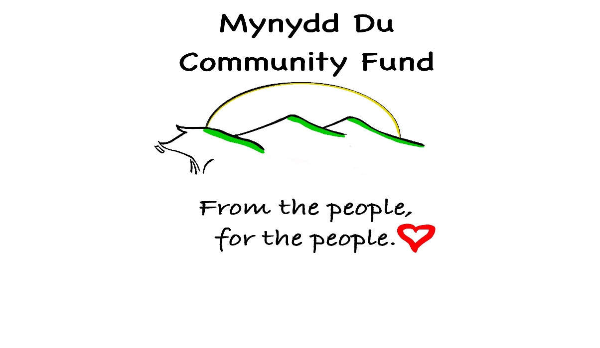

Application Form

Please return by 5pm on Friday 9th October 2020. Bids received after this time will NOT be considered. Applications forms can be sent to: Mynydddu.communityfund@gmail.com or delivered to Ammanford police station for the attention of PCSO Dayton Hughes.
Information about yourself/ Organisation/ Group

Name of
Organisation
Primary Purpose of the Organisation
Name of
Project
Name of
Main Contact
Position in the Organisation
Address and
Postcode
Main contact number:

Email

- What are you requesting funding for?
Explain what activities/services you will deliver with the funding. Max 200 words.

- Who will benefit from your project?
Explain what sections of the community will benefit.
- What key outcomes/results will your project achieve?

Please remember all bids must have a relationship to Improving and promoting wellbeing within the Cwmamman & Quarter Bach Community.

- Financial Information
How much funding are you bidding for and how will this be used? Maximum of £2,500.

BEFORE RETURNING YOUR APPLICATION FORM, HAVE YOU:

• Checked the criteria to ensure you are eligible to apply?
• Provided contact details of your organisation and project?
• Provided a clear description of the aims of the project and why it should be supported?
• Provided a bid amount?
• Completed ALL the sections of the application form?
• Signed and dated the application form? Please ensure the application form is submitted by 5pm on Friday 9th October 2020.
• The Bid contact MUST be able to attend the event on Saturday 7th November 2020 4pm-6pm

Successful applicants are invited to attend a presentation surgery. This will provide help/advice for your presentation. The date of the surgery will appear on the Mynydd du community fund Facebook page.

Conditions and Declaration

I hereby certify that the information contained in this application form is accurate and acknowledge that in the event of a grant being made, the application form and guidance notes will be the basis of a binding agreement.
- The bid contact MUST be able to attend the PB event scheduled on Saturday 7th November 2020 4pm-6pm (Due to the Corona Virus outbreak, the event will be held online (details will follow). All details will be on the Mynydd Du community fund Facebook/twitter pages.
- Any bid made will be used ONLY for the purposes for which it is granted.
- Any unspent monies MUST be returned in the form of a cheque payable to ‘Dyfed Powys Police’.
- I understand that failure to comply with the above requirements may result in the recovery of monies paid.
- Applicants MUST be willing to participate in any promotion in relation to the event
- Applications MUST be completed by 5pm Friday 9th October 2020.
- All programmes/projects/cause must be for legal purposes.
- All programmes/projects/cause and organisations must not be linked to any political activity.
- All programmes/projects/cause must be of benefit to all.

Name: _____________________________ Signature: ______________________________
Date: ______________________________ Position: _______________________________

THERE WILL BE A PROCESS OF REVIEWING THE BIDS TO ENSURE THAT THEY MEET THE ABOVE CRITERIA AND THAT THEY ARE LEGAL. IF YOU ARE SUCCESFULLY INVITED TO ATTEND THE NEXT STAGE OF THE PARTICIPATORY BUDGETTING EVENT YOU WILL BE NOTIFIED BY E-MAIL BY WEDNESDAY 14th OCTOBER 2020.

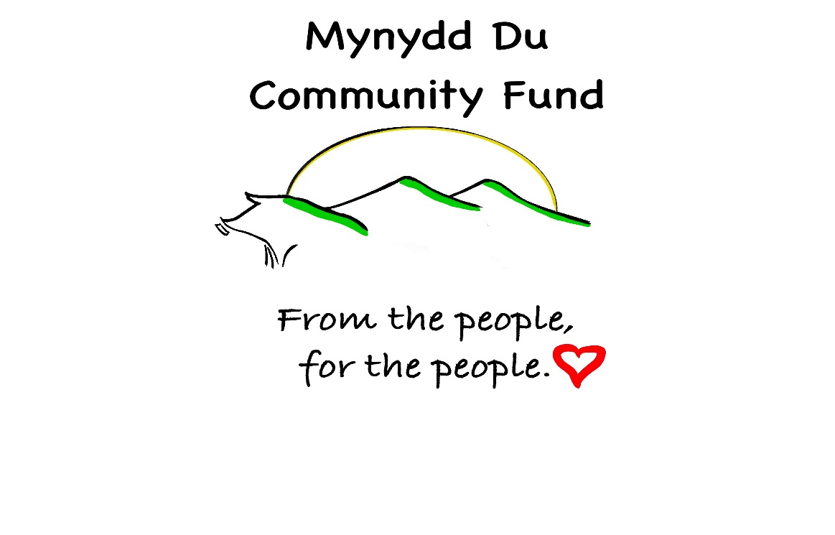

Diolch yn fawr
Thank you
We, the Mynydd Du Community Fund are committed to the principles inherent in the GDPR and particularly to the concepts of privacy. We aim to ensure: transparency with regard to the use of data; that any processing is lawful, fair, transparent and necessary for a specific purpose; that data is accurate, kept up to date and removed when no longer necessary, that data is kept safely and securely.

